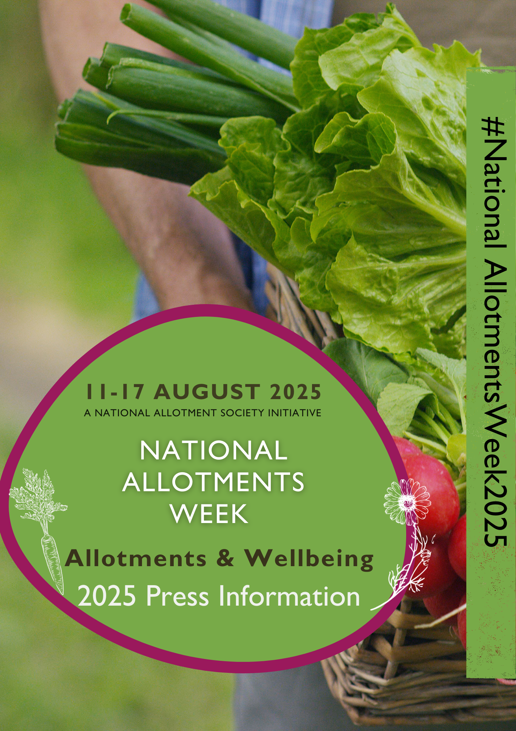

National Allotments Week 2025

Press Information

Who is the National Allotment Society (NAS)?
The National Allotment Society (NAS) is the leading national organisation upholding the interests and rights of the allotment community across the UK.
We work with government at national and local levels, other organisations and landlords to provide, promote and preserve allotments for all.
We offer support, guidance and advice to our members and those with an interest in allotment gardening.
In 2011, His Majesty King Charles III kindly agreed to become the Patron of the Society. The King is an avid gardener himself and advocate of green issues, he is also keen to promote and protect the UK's enduring traditions.

What Is National Allotments Week?
National Allotments Week, established in 2002, is an annual celebration dedicated to raising awareness of the vital role allotments play in promoting healthier lifestyles, sustainable living, and stronger communities. Spearheaded by the National Allotment Society, the event highlights the incredible benefits of allotments and encourages individuals, families, and communities to connect with the land and with each other.
Allotments have long been a cornerstone of sustainable living, offering people the opportunity to grow their own food, enjoy time outdoors, and adopt more active lifestyles. In addition to their physical and mental health benefits, allotments foster meaningful connections and friendships while contributing to the development of vibrant, cohesive communities.

Key Objectives of National Allotments Week:
- Promote Healthy Living: Allotments empower individuals to embrace healthier lifestyles by growing fresh, nutritious produce and engaging in physical activity.
- Champion Sustainability: Encouraging homegrown food reduces food miles, waste, and reliance on plastic packaging, supporting an eco-friendlier way of life.
- Strengthen Communities: Allotments bring people together, creating spaces where diverse groups can bond over shared goals, gardening tips, and harvest celebrations.
- Educate and Inspire: By sharing stories of allotment success, the event inspires more people to explore the joys of allotment gardening and sustainable living.
- Raise Awareness and Preservation: Promote allotments to those who may not know about them, while encouraging efforts to preserve and maintain these vital community resources.
Speaking about the significance of National Allotments Week, Mike Farrell, Chair of the National Allotment Society, said: “Allotments have always been more than just a place to grow food. They are hubs of community spirit, wellbeing, and environmental awareness. National Allotments Week is our chance to celebrate their enduring value and to invite others to experience the joys and rewards of allotment gardening.”
Previous National Allotment Week Themes
2024 - Biodiversity
2023 - Soil Health
2022 - Bugs, Bees and Broccoli
2021- Plotting for the Future
2020 - Growing Food for Health and Wellbeing
2019 - Shared Harvest
2018 - Living and Growing
2017 - Growing and Movement
2016 - Growing Together
2015 - A plot for all ages
2014 – Growing Together
2013- Party on the Plot
2012- Party on the Plot
Previous years focused on raising awareness of allotments with allotment competitions and open days without having a specific theme.

Fun Facts
- Allotments are often measured in poles (or rods), a traditional unit of measurement that equals 16.5 feet. This system comes from the old practice of using a "surveyor's rod" to measure land. Interestingly, 1 acre is the same as 160 poles, and this measurement is still used today in land surveys. So, when you hear about the size of an allotment, it might be measured in poles!
- Allotments are not just for everyday people – even famous figures have been known to enjoy them! For instance, Albert Einstein had an allotment in Berlin in 1922 when he was living there. At the time, he was reprimanded for neglecting his plot, with weeds taking over due to his busy schedule. In more recent years, former Labour Party leader Jeremy Corbyn is known for having his own allotment, where he grows fruit and even makes jam from his harvest.
- Many famous figures have found solace and joy in gardening, with several having their own vegetable patches. For example, Kate Moss is known to enjoy gardening and reportedly has a vegetable patch where she grows her own produce. David Beckham also has a vegetable garden at his home, where he tends to his crops. These famous faces, among others, show that allotments and vegetable patches aren’t just for the everyday gardener – they are enjoyed by some of the world’s most well-known individuals.
- A fun fact: The Good Life, the popular 1970s BBC sitcom, has had a huge comeback 46 years after it last aired, but with a twist! The show, which originally followed a couple trying to live self-sufficiently, has been revived as a theatre play. This revival highlights the growing interest in the "grow-your-own" lifestyle, showing how self-sufficiency and sustainability are still important today.
- In Birmingham, a comprehensive study on allotments revealed that 88% of plot-holders grow potatoes, making them the most commonly cultivated crop. Additionally, over three-quarters of plot-holders cultivate onions and shallots, brassicas, tomatoes, and courgettes.
- If added together, all the UKs allotments would equal 58 Hyde Parks

Key Figures
- Number of Allotments: As of 2021, there are approximately 330,000 allotment plots across the UK
- Average Plot Size: A standard allotment plot is traditionally 10 rods (also known as poles or perches), equating to about 250 square meters (approximately 2,690 square feet). However, due to increasing demand and the need for more manageable spaces, many have subdivided plots into smaller sizes, such as half plots (125 square meters) or even quarter plots (62.5 square meters)
- Waiting Lists: As of September 30, 2023, there are at least 157,820 outstanding applications for allotments in England, marking an 81% increase from 12 years ago (London Press)
- Demand: 87% of local authorities reported increased demand for allotments in 2024, and 47% are planning to expand their allotment provisions to meet this growing interest. (APSE)
- Members: The National Allotment Society has approximately 130,000 members over a 20% increase over the past five years.
- Membership: The National Allotment society offers 8 different types of membership: Individual, Life, Association, Affiliate, School, Landowner, Parish & Town Council, and Other Local Authority membership.
- Allotment holder age: As per the Birmingham allotment survey, the typical image of allotment holders has been of older men, but recent data shows a shift. More women are now taking on allotments, and there's a wider age range of plot-holders. While half are 65 or older, 20% are aged 30-49, and 30% are between 50-64. Most allotment holders work in professional jobs (44%), while 13% have manual jobs.
- Cost: Average Cost: In the UK, the average annual cost of an allotment typically ranges from £20 to £100. Urban areas tend to have higher fees compared to rural locations, with costs in cities such as London potentially being higher due to demand and limited availability.
- The National Allotment Society has 11 regional branches.
- Cost: To join the National Allotment Society is just £3.50 per year as an association member and £25 per year as an individual member. That’s less than 50p per week!!
- The last official government study was written in 1969 H. Thorpe, Departmental Committee of Inquiry into Allotments, London, Parliamentary Papers, 1969
- If added together, all the UKs allotments would equal 58 Hyde Parks
- Recent studies indicate a significant shift in the demographics of allotment holders in the UK. A 2024 report by the Association for Public Service Excellence (APSE) notes that, 20 years ago, the average age of an allotment holder was over 60, predominantly comprising retired individuals. However, this trend has changed, with a growing number of younger individuals engaging in allotment gardening.
- Over the past 6 years only 1 allotment site has been lost due to a Section 8 notice

What Happens During National Allotment Week
During the 7 days of National Allotments Week a number of exciting events will happen for our members the public and the media.
Survey Results
Since February, the National Allotment Society has been gathering data from allotment holders, including both members and non-members, to gain a deeper understanding of the value and impact of allotments across the UK.
The survey covers a variety of topics, including:
- Demographics: Insights into the age, gender, and backgrounds of allotment holders, highlighting the diverse and inclusive nature of the allotment community.
- Wellness Benefits: A look at the physical, mental, and emotional benefits of allotment gardening, from improved fitness and reduced stress to a greater sense of purpose and connection to nature.
- Cultivation Trends: Fun and fascinating facts about what’s being grown, from the most popular crops to unique and creative planting ideas.
We’re excited to announce that the full results of this survey will be revealed during National Allotments Week.

Member Events
During the week we will be hosting online events for our members to cover all aspects on wellbeing and allotments including.
Mental wellbeing and fraud prevention
Physical wellbeing
Nutritional wellbeing and food
Horticultural wellbeing and plant health
Surprise event
Public Events
Local sites will be opening their doors to the public to welcome people to different events. These could include quizzes, wellness on the plot events, open days, garden competitions and much more.
These will be announced as they are confirmed.

